 |  |  | 
产品名称 |  | 公司地址
产品编号 |  | 联系电话
备注

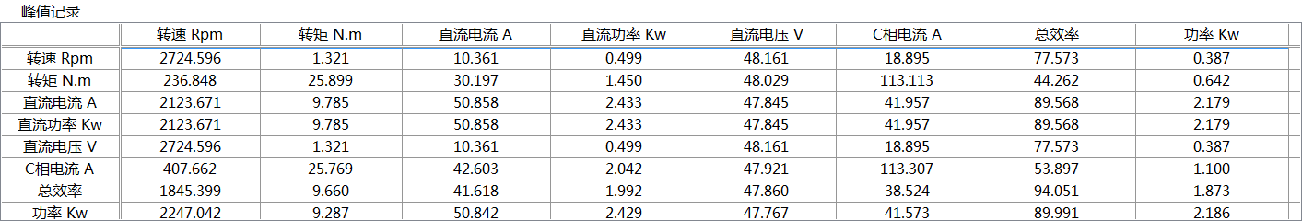

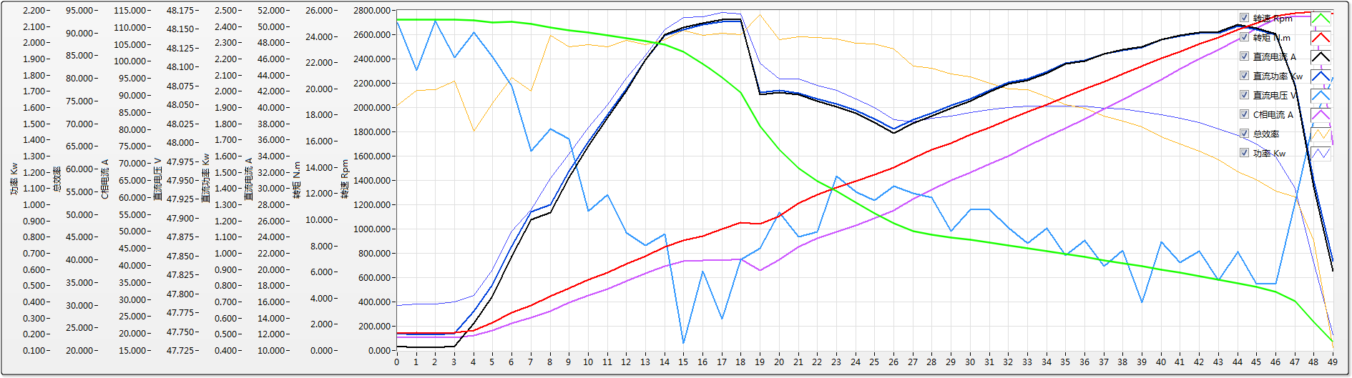
序号 | 转速 Rpm | 转矩 N.m | 直流电流 A | 直流功率 Kw | 直流电压 V | C相电流 A | 总效率 | 功率 Kw
0 | 2722.102 | 1.308 | 10.544 | 0.508 | 48.159 | 18.897 | 74.079 | 0.376
1 | 2721.033 | 1.344 | 10.384 | 0.499 | 48.096 | 18.795 | 77.417 | 0.387
2 | 2724.596 | 1.321 | 10.361 | 0.499 | 48.161 | 18.895 | 77.573 | 0.387
3 | 2721.627 | 1.382 | 10.506 | 0.505 | 48.113 | 18.850 | 79.346 | 0.401
4 | 2718.484 | 1.530 | 13.313 | 0.641 | 48.146 | 19.471 | 68.310 | 0.438
5 | 2699.275 | 2.107 | 16.716 | 0.804 | 48.114 | 20.805 | 74.541 | 0.600
6 | 2706.827 | 2.921 | 21.675 | 1.042 | 48.075 | 23.011 | 80.117 | 0.835
7 | 2687.823 | 3.461 | 26.146 | 1.255 | 47.989 | 24.594 | 77.187 | 0.968
8 | 2660.319 | 4.174 | 27.046 | 1.299 | 48.018 | 26.585 | 89.527 | 1.163
9 | 2637.111 | 4.758 | 31.395 | 1.507 | 48.005 | 29.097 | 87.024 | 1.312
10 | 2614.914 | 5.411 | 35.225 | 1.688 | 47.909 | 31.103 | 87.381 | 1.475
11 | 2592.060 | 5.958 | 38.750 | 1.857 | 47.931 | 33.103 | 86.995 | 1.616
12 | 2569.392 | 6.618 | 42.046 | 2.013 | 47.881 | 35.277 | 88.347 | 1.779
13 | 2545.235 | 7.221 | 45.883 | 2.196 | 47.864 | 37.716 | 87.444 | 1.920
14 | 2518.656 | 7.900 | 49.026 | 2.347 | 47.879 | 39.766 | 88.559 | 2.079
15 | 2459.058 | 8.385 | 49.843 | 2.379 | 47.734 | 41.285 | 90.665 | 2.157
16 | 2356.696 | 8.745 | 50.392 | 2.410 | 47.830 | 41.371 | 89.557 | 2.159
17 | 2247.042 | 9.287 | 50.842 | 2.429 | 47.767 | 41.573 | 89.991 | 2.186
18 | 2123.671 | 9.785 | 50.858 | 2.433 | 47.845 | 41.957 | 89.568 | 2.179
19 | 1845.399 | 9.660 | 41.618 | 1.992 | 47.860 | 38.524 | 94.051 | 1.873
20 | 1650.733 | 10.242 | 41.840 | 2.004 | 47.907 | 41.780 | 88.595 | 1.776
21 | 1502.366 | 11.250 | 41.550 | 1.989 | 47.875 | 45.478 | 89.235 | 1.775
22 | 1396.667 | 11.884 | 40.779 | 1.953 | 47.882 | 48.002 | 88.970 | 1.737
23 | 1309.428 | 12.440 | 40.070 | 1.922 | 47.956 | 49.973 | 88.762 | 1.706
24 | 1218.068 | 12.939 | 39.291 | 1.883 | 47.935 | 51.770 | 87.717 | 1.652
25 | 1132.232 | 13.463 | 38.139 | 1.828 | 47.924 | 53.939 | 87.579 | 1.601
26 | 1045.524 | 13.957 | 36.842 | 1.766 | 47.942 | 56.091 | 86.474 | 1.527
27 | 981.546 | 14.691 | 38.086 | 1.826 | 47.933 | 59.490 | 82.741 | 1.511
28 | 953.314 | 15.368 | 38.940 | 1.866 | 47.927 | 62.197 | 82.206 | 1.534
29 | 932.078 | 15.865 | 39.948 | 1.913 | 47.883 | 64.937 | 80.925 | 1.548
30 | 909.245 | 16.489 | 40.787 | 1.954 | 47.911 | 67.368 | 80.389 | 1.571
31 | 887.705 | 17.054 | 41.901 | 2.008 | 47.911 | 69.745 | 78.980 | 1.586
32 | 864.866 | 17.648 | 42.931 | 2.056 | 47.888 | 72.202 | 77.720 | 1.598
33 | 841.957 | 18.256 | 43.373 | 2.076 | 47.867 | 75.118 | 77.532 | 1.610
34 | 817.575 | 18.785 | 44.243 | 2.119 | 47.887 | 77.744 | 75.900 | 1.608
35 | 793.788 | 19.373 | 45.418 | 2.173 | 47.851 | 80.398 | 74.144 | 1.611
36 | 768.468 | 19.982 | 45.776 | 2.191 | 47.871 | 83.063 | 73.368 | 1.608
37 | 743.385 | 20.535 | 46.585 | 2.229 | 47.837 | 86.002 | 71.680 | 1.597
38 | 719.034 | 21.126 | 47.104 | 2.254 | 47.857 | 88.844 | 70.585 | 1.591
39 | 692.137 | 21.730 | 47.508 | 2.270 | 47.788 | 91.693 | 69.376 | 1.575
40 | 665.904 | 22.318 | 48.401 | 2.317 | 47.869 | 94.622 | 67.141 | 1.556
41 | 640.868 | 22.845 | 48.897 | 2.339 | 47.841 | 97.877 | 65.593 | 1.534
42 | 614.458 | 23.440 | 49.278 | 2.358 | 47.856 | 100.646 | 63.967 | 1.509
43 | 584.626 | 23.941 | 49.355 | 2.360 | 47.818 | 103.361 | 62.129 | 1.466
44 | 555.754 | 24.521 | 50.217 | 2.403 | 47.855 | 106.429 | 59.448 | 1.429
45 | 523.821 | 25.020 | 49.797 | 2.381 | 47.813 | 109.660 | 57.735 | 1.375
46 | 482.973 | 25.576 | 49.118 | 2.349 | 47.813 | 112.410 | 55.134 | 1.295
47 | 407.662 | 25.769 | 42.603 | 2.042 | 47.921 | 113.307 | 53.897 | 1.100
48 | 236.848 | 25.899 | 30.197 | 1.450 | 48.029 | 113.113 | 44.262 | 0.642
49 | 72.862 | 25.731 | 19.814 | 0.953 | 48.086 | 75.551 | 20.602 | 0.196

测试时间： 测试人员： 批准： 审核：

